Pressed Flower Prints!

Learning Objectives: Students will explore and identify the reproductive anatomy of flowers and understand the process of pollination by collecting colorful flowers around their neighborhood and pressing them to make greeting cards with!

Supplies:
- Collected flowers from neighborhood/ home
- Heavy book
- Glue or tape (modge podge is best)
- Paper
- Coloring Materials
- Paper Towel
Plan:
- Review Parts of a Plant: see diagram and review parts:
  - roots stabilize the plant and absorb water;
  - stems hold the plant up, connect all the parts, and transport water and nutrients;
  - leaves are the food factories of the plant- collecting sunlight and performing photosynthesis to create energy, they also produce oxygen for us to breathe (!);
  - flowers attract pollinators and eventually produce seeds;
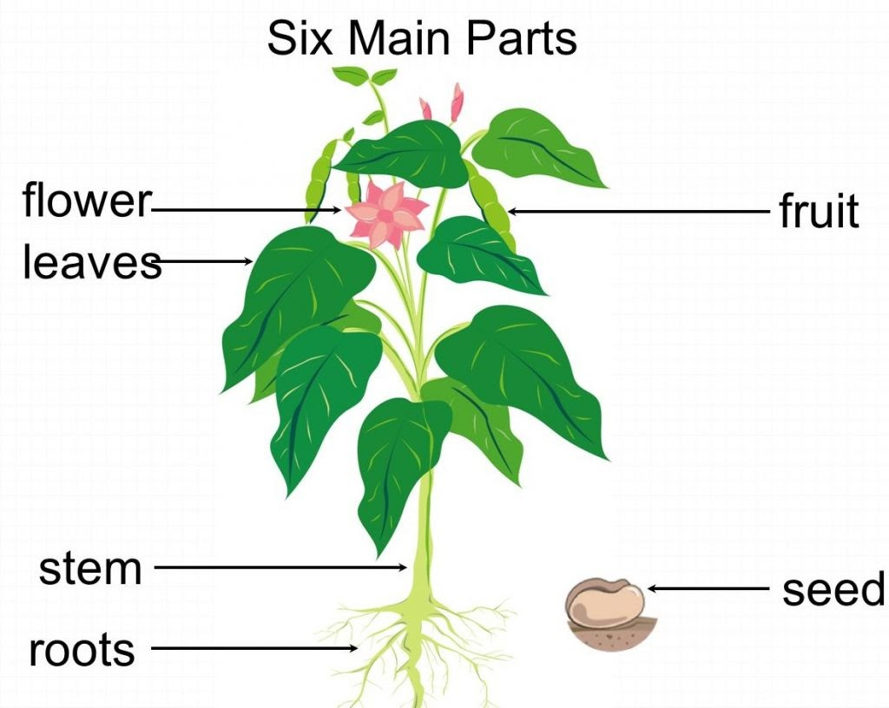
  - fruits are the suitcases of seeds, protecting them until they’re ready to grow; seeds produce more plants and continue the life cycle!

- Today we will be focusing on the flower! How do flowers help a plant grow? Flowers are the reproductive parts of plants that eventually make seeds and start a new plant life cycle.
- Watch Flower Anatomy & Pollination Youtube Video Link to study basic functions and parts of a flower.

Parts of a flower:
- Sepals- protects flower before it blooms
- Petals- provides a landing pad for insects and attracts with bright colors
- Pedicel- stem of a flower, hold individual flowers in place
- Receptacle- holds major organs
- Nectar Guide- directs insect towards nectar in center of flower
- Pistil: Stigma, Style, & Ovary- female part
  - stigma is sticky to receive pollen
  - Style long stalk
  - Ovary base of flower that holds eggs, contains Ovule- where seeds are made
- Stamen: Anther + Filament- male part-
  - pollen is on anther,
  - filament attaches antler to flower
  - 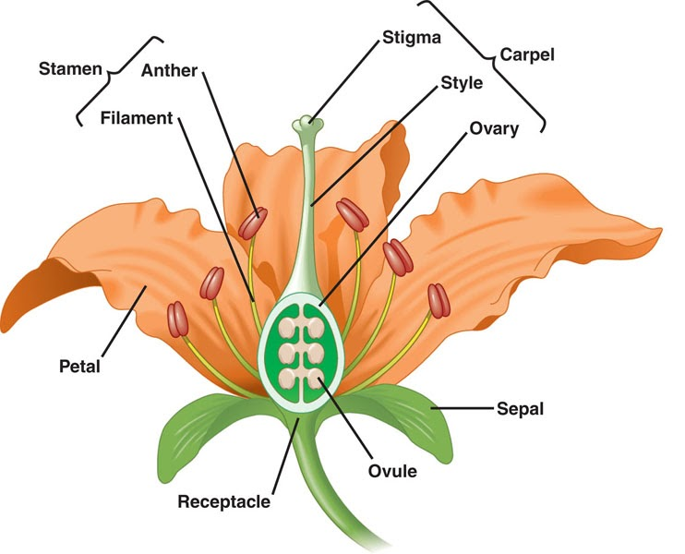
4. Making Flower Prints!
- Step 1: Explore your home, backyard or neighborhood to find a pretty flower!
- Step 2: Look closely at the flower to identify the sepals, petals, nectar guide, pistil & stigma, stamen & anther, and ovule!
- Step 3: Gather supplies!
- Step 4: PRESS! Lay your flower down on a paper towel or napkin and press gently. Then place your heavy book on top of the flower for 5 minutes.
- Step 5: While you wait for your flower to press, fold a piece of paper to make a greeting card and decorate it as you’d like!
- Step 6: Uncover the flower and glue or tape onto your greeting card! Can you label the parts?

